RIS DTD V1

Approach

The approach identified in design was to use the DocBook DTD and to modify it to become a slightly less technically focused dtd suitable for use in medical text books. In the design phase approximately 150 tags were identified as being technical in nature and identified for exclusion. See appendix B for the current list.

A RIS DTD was then created using the modules and entities defined in the docbook project using 6 modules to create a customization layer, depicted in shades of blue below. The DTD module, blue, replaces the docbook.dtd container. Three new modules where inserted before any DocBook modules, turquoise, and four were inserted at inserting points defined in the docbook standard, light blue there use is defined in the following table.

Rittdocbook.dtd | The main driver file. This module declares and references the other top-level modules. It is a copy of docbook.dtd with the inclusion of RittRedeclmeta.mod, RittRedeclmeta.mod and RittRedef.mod
RittRedeclmeta.mod | Module defines which of the next 4 modules are being used and the paths for modules that are used at the docbook insertion points, RittRedecl.mod and RittInterMod.mod
RittExclusions.mod | List of modules that are exclude in the dtd
RittRedef.mod | Redefinition of dbpool elements that occur before the predefined insertion point in dbpool.mod
RittInterMod.mod | Redefinition of dbhier elements that occur before the predefined insertion point in dbhier.mod. This is restricted to 2 mixes that have list types that we are not using.
Rittheir.mod | Redefinition of dbhier section elements that occur at the first predefined insertion point in dbhier.mod. This includes one attribute mix that has hierarchy classes.
Rittheir2.mod | Redefinition of dbhier section elements that occur at the second predefined insertion point in dbhier.mod. This is restricted extending the sect hierarchy.

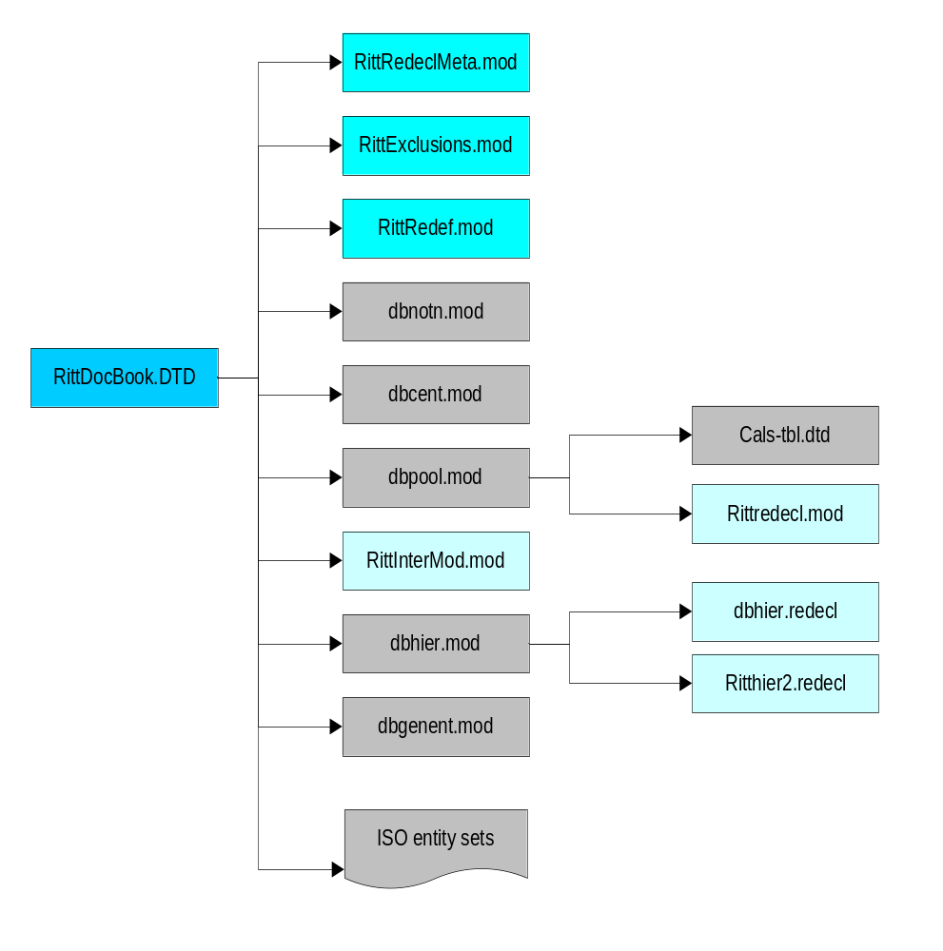The existing Docbook modules where not touched and are used as follows:
dbhier.mod | The hierarchy module declares the elements that provide the hierarchical structure of DocBook (sets, books, chapters, articles, etc.).
dbpool.mod | The information pool module declares the elements that describe content but are not part of the large-scale hierarchy of a document.
dbnotn.mod | The notation module declares the notations used by DocBook.
dbcent.mod | The character entity module declares and references the ISO entity sets used by DocBook.
dbgenent.mod | Place holder for adding user defined general entities.
cals-tbl.dtd | The CALS table model, published in MIL-HDBK-28001, is the table model used by DocBook.
ISO | The ISO standard character entity sets. These entity sets are not actually part of the official DocBook distribution, but are referenced by default.

Comments on changes

When reviewing the changes the following types of elements account for the vast majority of excluded elements: purely technical elements, callouts and specialty list elements.

Since the exclusions where mainly to pool elements there were very few changes at the hierarchy level or between the hierarchy and pool modules. Those that did occur were often cases where a multi-valued parameter in the pool ends up being totally empty and the or character “|” is used in the dependant element instead of being declared in the parameter.

Since the customization layer is separate from the DocBook modules upgrades to subsequent versions should relatively easy as the modules need just to be replaced and then you need to recompile.

The sectX hierarchy was extended to support a greater number of levels.

Differences from the original specification
The following elements where added to the excluded list:
interface | An element of a GUI
imageobjectco | A wrapper for an image object with callouts
citebiblioid | A citation of a bibliographic identifier
co | The location of a callout embedded in text
coref | A cross reference to a co
medialabel | A name that identifies the physical medium on which some information resides
modifier | Modifiers in a synopsis
refclass | The scope or other indication of applicability of a reference entry
refdescriptor | A description of the topic of a reference page
refentry | A reference page (originally a UNIX man-style reference page)
refentryinfo | Meta-information for a Refentry
refentrytitle | The title of a reference page
reference | A collection of reference entries
referenceinfo | Meta-information for a Reference
refmeta | Meta-information for a reference entry
refmiscinfo | Meta-information for a reference entry other than the title and volume number
refname | The name of (one of) the subject(s) of a reference page
refnamediv | The name, purpose, and classification of a reference page
refpurpose | A short (one sentence) synopsis of the topic of a reference page
refsect1 | A major subsection of a reference entry
refsect1info | Meta-information for a RefSect1
refsect2 | A subsection of a RefSect1
refsect2info | Meta-information for a RefSect2
refsect3 | A subsection of a RefSect2
refsect3info | Meta-information for a RefSect3
refsection | A recursive section in a refentry
refsectioninfo | Meta-information for a refsection
refsynopsisdiv | A syntactic synopsis of the subject of the reference page
refsynopsisdivinfo | Meta-information for a RefSynopsisDiv
remark | A remark (or comment) intended for presentation in a draft manuscript
symbol | A name that is replaced by a value before processing
token | A unit of information

The following elements that were initially identified as exclusion candidates were retained.
anchor | A spot in the document
beginpage | The location of a page break in a print version of the document
simplesect | A section of a document with no subdivisions
synopsis | A general-purpose element for representing the syntax of commands or functions

The following new elements are added to the DocBook DTD

degree | The degree held by a personname
sect6-sect10 | Additional chapter sections
sect6info-sect10info | Additional info types for the chapter sections.

Appendix:A
Notes setting up environments:
Local checking against a SYSTEM dtd
- Set up book structure as detailed above
- Install SP a smgl package such as the package from http://jclark.com/sp
- Add <SP>/bin to path
- Modify the docbook catalog.xml file to use the local directory structure. For v1 this was just modified to use local entity references. And the module references were removed.
- Create a valid xml document to test the DTD against. It doesn’t have to have comprehensive element usage as the nsmgl command with the –wall flag checks the DTD completely.
- Run SP the parser, nsgml, with the following arguments to check the unmodified DTD for validity.
> nsgmls.exe -sv -wxml -D"." -D".\ent" -c catalog.xml -E1000 -ftmp.txt -c "C:\Program Files\jclark\nsgmls\pubtext\xml.soc" -wall demo2.xml
Note: replace C:\Program Files\jclark\nsgmls\
- Modify the DTD and keep running nsgml until it runs without errors and a minimum of warnings. You may not be able to get rid of all of the warnings as you are causing parts of the code to be ignored and that will cause some parameters set but not used warnings.

Web validation, PUBLIC dtd

- Place DTD files on a web server.
- Make sure that the sever is configured to serve *.dtd, *.ent and *.mod files
- Change .xml files to validate against the PUBLIC dtd at the site.

Appendix B currently included elements Added in Red
abbrev | An abbreviation, especially one followed by a period
abstract | A summary
ackno | Acknowledgements in an Article
acronym | An often pronounceable word made from the initial (or selected) letters of a name or phrase
address | A real-world address, generally a postal address
affiliation | The institutional affiliation of an individual
anchor | A spot in the document
answer | An answer to a question posed in a QandASet
appendix | An appendix in a Book or Article
appendixinfo | Meta-information for an Appendix
article | An article
articleinfo | Meta-information for an Article
artpagenums | The page numbers of an article as published
attribution | The source of a block quote or epigraph
audiodata | Pointer to external audio data
audioobject | A wrapper for audio data and its associated meta-information
author | The name of an individual author
authorblurb | A short description or note about an author
authorgroup | Wrapper for author information when a document has multiple authors or collabarators
authorinitials | The initials or other short identifier for an author
beginpage | The location of a page break in a print version of the document
bibliocoverage | The spatial or temporal coverage of a document
bibliodiv | A section of a Bibliography
biblioentry | An entry in a Bibliography
bibliography | A bibliography
bibliographyinfo | Meta-information for a Bibliography
biblioid | An identifier for a document
bibliomisc | Untyped bibliographic information
bibliomixed | An entry in a Bibliography
bibliomset | A cooked container for related bibliographic information
bibliorelation | The relationship of a document to another
biblioset | A raw container for related bibliographic information
bibliosource | The source of a document
blockinfo | Meta-information for a block element
blockquote | A quotation set off from the main text
book | A book
bookinfo | Meta-information for a Book
bridgehead | A free-floating heading
caption | A caption
caution | A note of caution
chapter | A chapter, as of a book
chapterinfo | Meta-information for a Chapter
citation | An inline bibliographic reference to another published work
citerefentry | A citation to a reference page
citetitle | The title of a cited work
city | The name of a city in an address
col | Specifications for a column in an HTML table
colgroup | A group of columns in an HTML table
collab | Identifies a collaborator
collabname | The name of a collaborator
colophon | Text at the back of a book describing facts about its production
colspec | Specifications for a column in a table
contractnum | The contract number of a document
contrib | A summary of the contributions made to a document by a credited source
copyright | Copyright information about a document
corpauthor | A corporate author, as opposed to an individual
corpcredit | A corporation or organization credited in a document
corpname | The name of a corporation
country | The name of a country
database | The name of a database, or part of a database
date | The date of publication or revision of a document
dedication | A wrapper for the dedication section of a book
edition | The name or number of an edition of a document
editor | The name of the editor of a document
email | An email address
emphasis | Emphasized text
entry | A cell in a table
entrytbl | A subtable appearing in place of an Entry in a table
epigraph | A short inscription at the beginning of a document or component
equation | A displayed mathematical equation
fax | A fax number
figure | A formal figure, generally an illustration, with a title
filename | The name of a file
firstname | The first name of a person
firstterm | The first occurrence of a term
footnote | A footnote
footnoteref | A cross reference to a footnote (a footnote mark)
foreignphrase | A word or phrase in a language other than the primary language of the document
formalpara | A paragraph with a title
glossary | A glossary
glossaryinfo | Meta-information for a Glossary
glossdef | A definition in a GlossEntry
glossdiv | A division in a Glossary
glossentry | An entry in a Glossary or GlossList
glosslist | A wrapper for a set of GlossEntrys
glosssee | A cross-reference from one GlossEntry to another
glossseealso | A cross-reference from one GlossEntry to another
glossterm | A glossary term
graphic | A displayed graphical object (not an inline)
highlights | A summary of the main points of the discussed component
holder | The name of the individual or organization that holds a copyright
honorific | The title of a person
imagedata | Pointer to external image data
imageobject | A wrapper for image data and its associated meta-information
index | An index
indexdiv | A division in an index
indexentry | An entry in an index
indexinfo | Meta-information for an Index
indexterm | A wrapper for terms to be indexed
inlinegraphic | An object containing or pointing to graphical data that will be rendered inline
inlinemediaobject | An inline media object (video, audio, image, and so on)
invpartnumber | An inventory part number
isbn | The International Standard Book Number of a document
issn | The International Standard Serial Number of a periodical
issuenum | The number of an issue of a journal
itemizedlist | A list in which each entry is marked with a bullet or other dingbat
itermset | A set of index terms in the meta-information of a document
jobtitle | The title of an individual in an organization
label | A label on a Question or Answer
legalnotice | A statement of legal obligations or requirements
lineage | The portion of a person's name indicating a relationship to ancestors
link | A hypertext link
listitem | A wrapper for the elements of a list item
literal | Inline text that is some literal value
literallayout | A block of text in which line breaks and white space are to be reproduced faithfully
lot | A list of the titles of formal objects (as tables or figures) in a document
lotentry | An entry in a list of titles
manvolnum | A reference volume number
mediaobject | A displayed media object (video, audio, image, etc.)
member | An element of a simple list
mml:math | A MathML equation
objectinfo | Meta-information for an object
orderedlist | A list in which each entry is marked with a sequentially incremented label
orgdiv | A division of an organization
orgname | The name of an organization other than a corporation
otheraddr | Uncategorized information in address
othercredit | A person or entity, other than an author or editor, credited in a document
othername | A component of a persons name that is not a first name, surname, or lineage
pagenums | The numbers of the pages in a book, for use in a bibliographic entry
para | A paragraph
part | A division in a book
partinfo | Meta-information for a Part
partintro | An introduction to the contents of a part
personblurb | A short description or note about a person
personname | The personal name of an individual
phone | A telephone number
phrase | A span of text
pob | A post office box in an address
postcode | A postal code in an address
preface | Introductory matter preceding the first chapter of a book
prefaceinfo | Meta-information for a Preface
primary | The primary word or phrase under which an index term should be sorted
primaryie | A primary term in an index entry, not in the text
printhistory | The printing history of a document
productname | The formal name of a product
productnumber | A number assigned to a product
pubdate | The date of publication of a document
publisher | The publisher of a document
publishername | The name of the publisher of a document
pubsnumber | A number assigned to a publication other than an ISBN or ISSN or inventory part number
qandadiv | A titled division in a QandASet
qandaentry | A question/answer set within a QandASet
qandaset | A question-and-answer set
question | A question in a QandASet
quote | An inline quotation
releaseinfo | Information about a particular release of a document
revdescription | A extended description of a revision to a document
revhistory | A history of the revisions to a document
revision | An entry describing a single revision in the history of the revisions to a document
revnumber | A document revision number
revremark | A description of a revision to a document
row | A row in a table
secondary | A secondary word or phrase in an index term
secondaryie | A secondary term in an index entry, rather than in the text
sect1 | A top-level section of document
sect1info | Meta-information for a Sect1
sect2 | A subsection within a Sect1
sect2info | Meta-information for a Sect2
sect3 | A subsection within a Sect2
sect3info | Meta-information for a Sect3
sect4 | A subsection within a Sect3
sect4info | Meta-information for a Sect4
sect5 | A subsection within a Sect4
sect5info | Meta-information for a Sect5
section | A recursive section
sectioninfo | Meta-information for a recursive section
see | Part of an index term directing the reader instead to another entry in the index
seealso | Part of an index term directing the reader also to another entry in the index
seealsoie | A See also entry in an index, rather than in the text
seeie | A See entry in an index, rather than in the text
seriesvolnums | Numbers of the volumes in a series of books
set | A collection of books
setindex | An index to a set of books
setindexinfo | Meta-information for a SetIndex
setinfo | Meta-information for a Set
shortaffil | A brief description of an affiliation
sidebar | A portion of a document that is isolated from the main narrative flow
sidebarinfo | Meta-information for a Sidebar
simplesect | A section of a document with no subdivisions
spanspec | Formatting information for a spanned column in a table
state | A state or province in an address
street | A street address in an address
subject | One of a group of terms describing the subject matter of a document
subjectset | A set of terms describing the subject matter of a document
subjectterm | A term in a group of terms describing the subject matter of a document
subscript | A subscript (as in H2O, the molecular formula for water)
subtitle | The subtitle of a document
superscript | A superscript (as in x2, the mathematical notation for x multiplied by itself)
surname | A family name; in western cultures the last name
synopsis | A general-purpose element for representing the syntax of commands or functions
table | A formal table in a document
tbody | A wrapper for the rows of a table or informal table
td | A table entry in an HTML table
term | The word or phrase being defined or described in a variable list
tertiary | A tertiary word or phrase in an index term
tertiaryie | A tertiary term in an index entry, rather than in the text
textdata | Pointer to external text data
textobject | A wrapper for a text description of an object and its associated meta-information
tfoot | A table footer consisting of one or more rows
tgroup | A wrapper for the main content of a table, or part of a table
th | A table header entry in an HTML table
thead | A table header consisting of one or more rows
tip | A suggestion to the user, set off from the text
title | The text of the title of a section of a document or of a formal block-level element
titleabbrev | The abbreviation of a Title
toc | A table of contents
tocback | An entry in a table of contents for a back matter component
tocchap | An entry in a table of contents for a component in the body of a document
tocentry | A component title in a table of contents
tocfront | An entry in a table of contents for a front matter component
toclevel1 | A top-level entry within a table of contents entry for a chapter-like component
toclevel2 | A second-level entry within a table of contents entry for a chapter-like component
toclevel3 | A third-level entry within a table of contents entry for a chapter-like component
toclevel4 | A fourth-level entry within a table of contents entry for a chapter-like component
toclevel5 | A fifth-level entry within a table of contents entry for a chapter-like component
tocpart | An entry in a table of contents for a part of a book
tr | A row in an HTML table
trademark | A trademark
type | The classification of a value
ulink | A link that addresses its target by means of a URL (Uniform Resource Locator)
uri | A Uniform Resource Identifier
videodata | Pointer to external video data
videoobject | A wrapper for video data and its associated meta-information
volumenum | The volume number of a document in a set (as of books in a set or articles in a journal)
warning | An admonition set off from the text
wordasword | A word meant specifically as a word and not representing anything else
xref | A cross reference to another part of the document
Year | The year of publication of a document

Appendix C Currently excluded elements.
accel | A graphical user interface (GUI) keyboard shortcut
action | A response to a user event
alt | Text representation for a graphical element
application | The name of a software program
area | A region defined for a Callout in a graphic or code example
areaset | A set of related areas in a graphic or code example
areaspec | A collection of regions in a graphic or code example
arg | An argument in a CmdSynopsis
callout | A “called out” description of a marked Area
calloutlist | A list of Callouts
citebiblioid | A citation of a bibliographic identifier
classname | The name of a class, in the object-oriented programming sense
classsynopsis | The syntax summary for a class definition
classsynopsisinfo | Information supplementing the contents of a ClassSynopsis
cmdsynopsis | A syntax summary for a software command
co | The location of a callout embedded in text
code | An inline code fragment
command | The name of an executable program or other software command
computeroutput | Data, generally text, displayed or presented by a computer
confdates | The dates of a conference for which a document was written
confgroup | A wrapper for document meta-information about a conference
confnum | An identifier, frequently numerical, associated with a conference for which a document was written
confsponsor | The sponsor of a conference for which a document was written
conftitle | The title of a conference for which a document was written
constant | A programming or system constant
constraint | A constraint in an EBNF production
constraintdef | The definition of a constraint in an EBNF production
constructorsynopsis | A syntax summary for a constructor
contractsponsor | The sponsor of a contract
coref | A cross reference to a co
destructorsynopsis | A syntax summary for a destructor
envar | A software environment variable
errorcode | An error code
errorname | An error name
errortext | An error message.
errortype | The classification of an error message
example | A formal example, with a title
exceptionname | The name of an exception
fieldsynopsis | The name of a field in a class definition
funcdef | A function (subroutine) name and its return type
funcparams | Parameters for a function referenced through a function pointer in a synopsis
funcprototype | The prototype of a function
funcsynopsis | The syntax summary for a function definition
funcsynopsisinfo | Information supplementing the FuncDefs of a FuncSynopsis
function | The name of a function or subroutine, as in a programming language
graphicco | A graphic that contains callout areas
group | A group of elements in a CmdSynopsis
guibutton | The text on a button in a GUI
guiicon | Graphic and/or text appearing as a icon in a GUI
guilabel | The text of a label in a GUI
guimenu | The name of a menu in a GUI
guimenuitem | The name of a terminal menu item in a GUI
guisubmenu | The name of a submenu in a GUI
hardware | A physical part of a computer system
html:form | An HTML form
imageobjectco | A wrapper for an image object with callouts
important | An admonition set off from the text
informalequation | A displayed mathematical equation without a title
informalexample | A displayed example without a title
informalfigure | A untitled figure
informaltable | A table without a title
initializer | The initializer for a FieldSynopsis
inlineequation | A mathematical equation or expression occurring inline
interface | An element of a GUI
interfacename | The name of an interface
keycap | The text printed on a key on a keyboard
keycode | The internal, frequently numeric, identifier for a key on a keyboard
keycombo | A combination of input actions
keysym | The symbolic name of a key on a keyboard
keyword | One of a set of keywords describing the content of a document
keywordset | A set of keywords describing the content of a document
lhs | The left-hand side of an EBNF production
lineannotation | A comment on a line in a verbatim listing
markup | A string of formatting markup in text that is to be represented literally
medialabel | A name that identifies the physical medium on which some information resides
mediaobjectco | A media object that contains callouts
menuchoice | A selection or series of selections from a menu
methodname | The name of a method
methodparam | Parameters to a method
methodsynopsis | A syntax summary for a method
modespec | Application-specific information necessary for the completion of an OLink
modifier | Modifiers in a synopsis
mousebutton | The conventional name of a mouse button
msg | A message in a message set
msgaud | The audience to which a message in a message set is relevant
msgentry | A wrapper for an entry in a message set
msgexplan | Explanatory material relating to a message in a message set
msginfo | Information about a message in a message set
msglevel | The level of importance or severity of a message in a message set
msgmain | The primary component of a message in a message set
msgorig | The origin of a message in a message set
msgrel | A related component of a message in a message set
msgset | A detailed set of messages, usually error messages
msgsub | A subcomponent of a message in a message set
msgtext | The actual text of a message component in a message set
nonterminal | A non-terminal in an EBNF production
note | A message set off from the text
olink | A link that addresses its target indirectly, through an entity
ooclass | A class in an object-oriented programming language
ooexception | An exception in an object-oriented programming language
oointerface | An interface in an object-oriented programming language
option | An option for a software command
optional | Optional information
paramdef | Information about a function parameter in a programming language
parameter | A value or a symbolic reference to a value
procedure | A list of operations to be performed in a well-defined sequence
production | A production in a set of EBNF productions
productionrecap | A cross-reference to an EBNF production
productionset | A set of EBNF productions
programlisting | A literal listing of all or part of a program
programlistingco | A program listing with associated areas used in callouts
prompt | A character or string indicating the start of an input field in a computer display
property | A unit of data associated with some part of a computer system
refclass | The scope or other indication of applicability of a reference entry
refdescriptor | A description of the topic of a reference page
refentry | A reference page (originally a UNIX man-style reference page)
refentryinfo | Meta-information for a Refentry
refentrytitle | The title of a reference page
reference | A collection of reference entries
referenceinfo | Meta-information for a Reference
refmeta | Meta-information for a reference entry
refmiscinfo | Meta-information for a reference entry other than the title and volume number
refname | The name of (one of) the subject(s) of a reference page
refnamediv | The name, purpose, and classification of a reference page
refpurpose | A short (one sentence) synopsis of the topic of a reference page
refsect1 | A major subsection of a reference entry
refsect1info | Meta-information for a RefSect1
refsect2 | A subsection of a RefSect1
refsect2info | Meta-information for a RefSect2
refsect3 | A subsection of a RefSect2
refsect3info | Meta-information for a RefSect3
refsection | A recursive section in a refentry
refsectioninfo | Meta-information for a refsection
refsynopsisdiv | A syntactic synopsis of the subject of the reference page
refsynopsisdivinfo | Meta-information for a RefSynopsisDiv
remark | A remark (or comment) intended for presentation in a draft manuscript
replaceable | Content that may or must be replaced by the user
returnvalue | The value returned by a function
rhs | The right-hand side of an EBNF production
sbr | An explicit line break in a command synopsis
screen | Text that a user sees or might see on a computer screen
screenco | A screen with associated areas used in callouts
screeninfo | Information about how a screen shot was produced
screenshot | A representation of what the user sees or might see on a computer screen
seg | An element of a list item in a segmented list
seglistitem | A list item in a segmented list
segmentedlist | A segmented list, a list of sets of elements
segtitle | The title of an element of a list item in a segmented list
sgmltag | A component of SGML markup
shortcut | A key combination for an action that is also accessible through a menu
simpara | A paragraph that contains only text and inline markup, no block elements
simplelist | An undecorated list of single words or short phrases
simplemsgentry | A wrapper for a simpler entry in a message set
step | A unit of action in a procedure
stepalternatives | Alternative steps in a procedure
structfield | A field in a structure (in the programming language sense)
structname | The name of a structure (in the programming language sense)
substeps | A wrapper for steps that occur within steps in a procedure
svg:svg | An SVG graphic
symbol | A name that is replaced by a value before processing
synopfragment | A portion of a CmdSynopsis broken out from the main body of the synopsis
synopfragmentref | A reference to a fragment of a command synopsis
systemitem | A system-related item or term
task | A task to be completed
taskprerequisites | The prerequisites for a task
taskrelated | Information related to a task
tasksummary | A summary of a task
token | A unit of information
userinput | Data entered by the user
varargs | An empty element in a function synopsis indicating a variable number of arguments
variablelist | A list in which each entry is composed of a set of one or more terms and an associated description
varlistentry | A wrapper for a set of terms and the associated description in a variable list
varname | The name of a variable
void | An empty element in a function synopsis indicating that the function in question takes no arguments

